

**FACULTY OF ENGINEERING, SCIENCE AND TECHNOLOGY**

**DEPARTMENT OF COMPUTER SCIENCE**

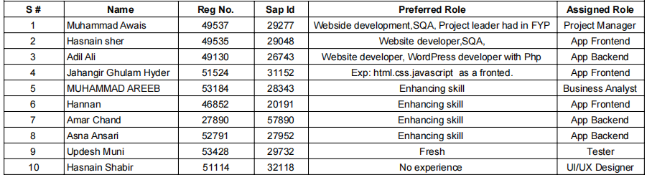

**ROJECT:**

**Shopkeeper Inventory and POS App**

**COORDINATOR NAME:**

**Daniyal Nawaz**

**Jan/26/ 2024**

Shopkeeper Inventory and POS App Features

**Inventory Management:**

* Add, update, and delete products with relevant details (name, price, quantity, etc.).
* Categorize products for easy organization.
* Real-time inventory tracking.
* Low stock notifications to prevent stockouts.
* Barcode scanning for quick product entry.

**2. Point-of-Sale (POS) System:**

* Efficient checkout process.
* Support for multiple payment methods (cash, card, digital payments).
* Generation of digital receipts.
* Integration with receipt printers and card payment terminals.

**3. User Authentication and Security:**

* Secure login for shopkeepers with role-based access control.
* Password encryption and secure session management.
* Access logs for security auditing.

**4. Reporting and Analytics:**

* Sales reports for a specified period.
* Analytics dashboard for insights into popular products, sales trends, and customer behavior.
* Exportable reports for accounting purposes.

**5. Barcode Scanning Integration:**

* Recognize and process standard barcode formats.
* Use the device camera for barcode scanning.
* Quick addition of products to the inventory.

**6. Offline Mode:**

* Basic functionality accessible even without an internet connection.
* Automatic synchronization of data when the device reconnects.

**7. Customization Options:**

* Settings for tax rates, currency, and other preferences.
* Customizable receipts with shop branding.

**8. Customer Management:**

* Create and manage customer profiles.
* Track customer purchase history and preferences.
* Loyalty program support.

**9. Purchase Orders:**

* Create, manage, and track purchase orders for restocking.
* Automated restocking alerts.

**10. Multi-Location Support: -**

Manage inventory and POS operations for multiple shop locations. - Centralized reporting and analytics across locations.

**11. User-Friendly Interface: -**

Intuitive and visually appealing design. - Easy navigation for both shopkeepers and customers.

**12. Security and Compliance: -**

Compliance with data protection and privacy regulations. - Secure data storage and transmission.

**13. Notifications: -**

Alerts for low stock, successful transactions, or system updates. - Push notifications for important updates.

**14. Integration with External Systems: -**

Integration with accounting software for seamless financial management. - Integration with eCommerce platforms for online sales.

**15. Customer Support and Training: -**

Multi-channel customer support (email, chat, helpline). - Help center with documentation. - Training materials for shopkeepers.

**16. Updates and Maintenance: -**

Regular updates for performance improvements and bug fixes. - Notification system for new features or updates.

**17. Scalability: -**

Design for scalability to accommodate growing inventory and business needs. - Support for additional features and modules in the future.